User Guide – SUMO Traffic Simulation Control System
1. Introduction and System Overview
The SUMO Traffic Simulation Control System is a Java-based application designed to control and visualize traffic simulations executed in SUMO. The system uses the libtraci interface to establish a live connection between the application and the SUMO simulator. Through this connection, the application enables real-time simulation control, vehicle injection, traffic light monitoring, and basic traffic statistics. The goal of the system is to provide a functional prototype that demonstrates core traffic simulation management features in an intuitive graphical user interface.

2. Setup and SUMO Connection
To use the application, the user must have a compatible Java Development Kit and a local installation of SUMO. After starting the application, a valid SUMO configuration file (.sumocfg) must be selected via the file selection dialog. Once the configuration file is loaded, the user can establish a connection to SUMO by clicking the “Connect SUMO” button. A successful connection is indicated by a green status indicator, confirming that the TraCI interface is active and the simulation is ready to be controlled from the application.
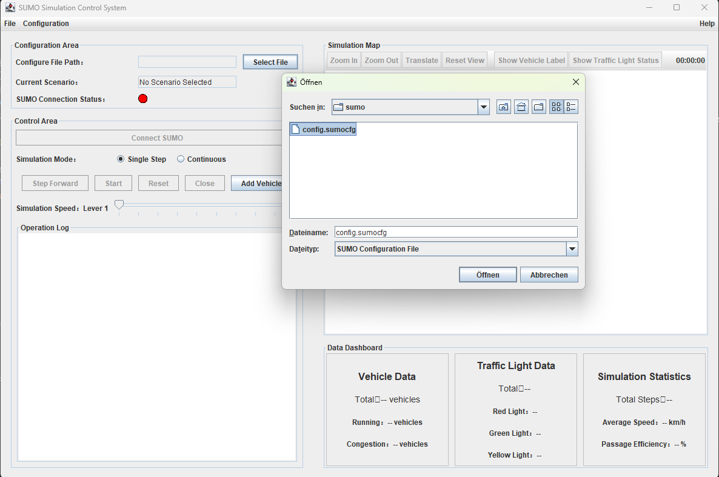

3. Simulation Control and Visualization
The application provides both single-step and continuous simulation modes. In single-step mode, the simulation advances one step at a time, allowing detailed observation of traffic behavior. In continuous mode, the simulation runs automatically with adjustable speed. The application includes a simplified map visualization that displays roads, vehicles, and traffic lights in real time. Vehicles move according to the SUMO simulation, and traffic light states are visually distinguished by color. The visualization focuses on functional correctness rather than full geometric accuracy and supports basic interaction such as zooming, panning, and view reset.

4. Vehicle Injection, Traffic Lights, and Statistics
Vehicles can be dynamically injected into the running simulation using the “Add Vehicle” button. Each injected vehicle is assigned a valid route and departs immediately, appearing both in the SUMO GUI and in the custom application visualization. Internal SUMO routes are automatically filtered and not used for vehicle injection. The system continuously monitors traffic lights and displays their current states in the interface. In addition, a statistics dashboard provides real-time information such as the total number of vehicles, running and congested vehicles, traffic light counts, average speed, traffic efficiency, and total simulation steps.

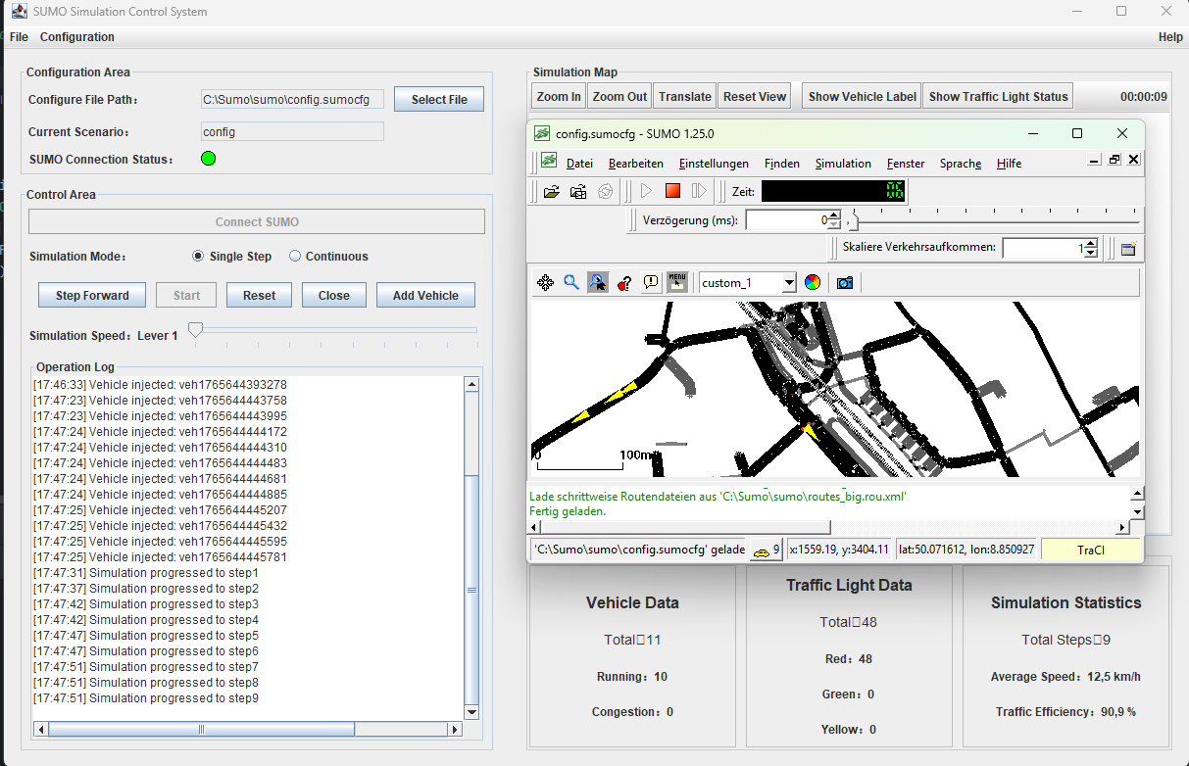
5. Test Scenario, Limitations, and Conclusion
The functionality of the prototype can be validated through a simple stress test by injecting multiple vehicles during a running simulation and observing system stability and traffic behavior. While the application successfully demonstrates all core features required for the functional prototype, certain limitations remain. The map visualization is abstracted, and routing is limited to predefined or dynamically created valid routes. Internal SUMO warning messages may occur but do not affect system functionality. Overall, the SUMO Traffic Simulation Control System fulfills the requirements of Milestone 2 by providing a stable, functional prototype with live simulation control, visualization, and data monitoring capabilities.

